

Our Savior Lutheran

**Tenth Sunday After Pentecost**

July 28, 2024

592 Dearest Jesus, We Are Here

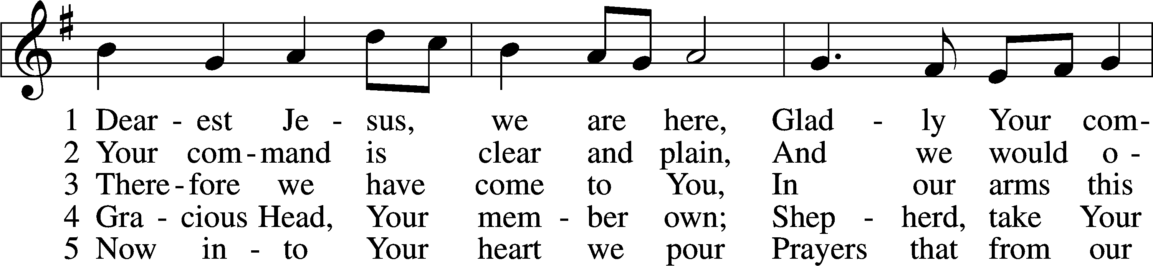

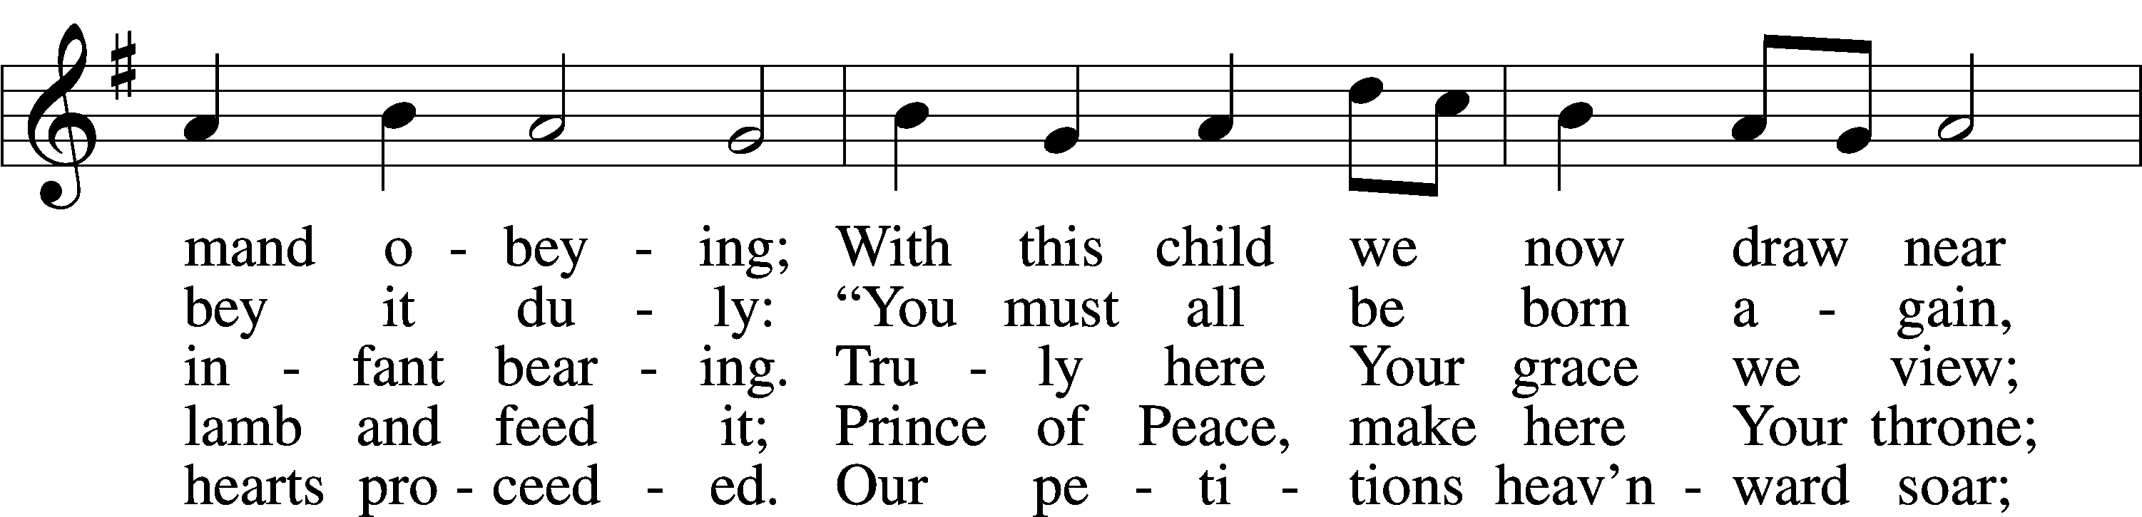

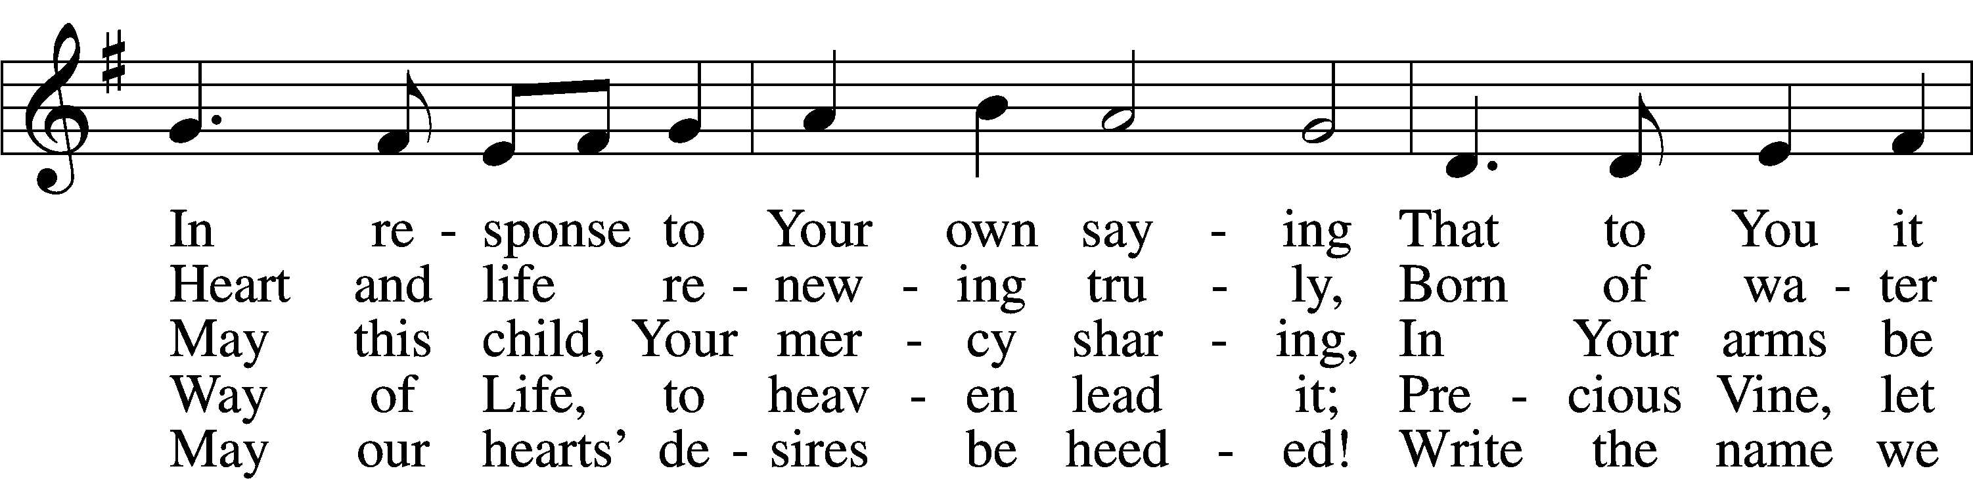

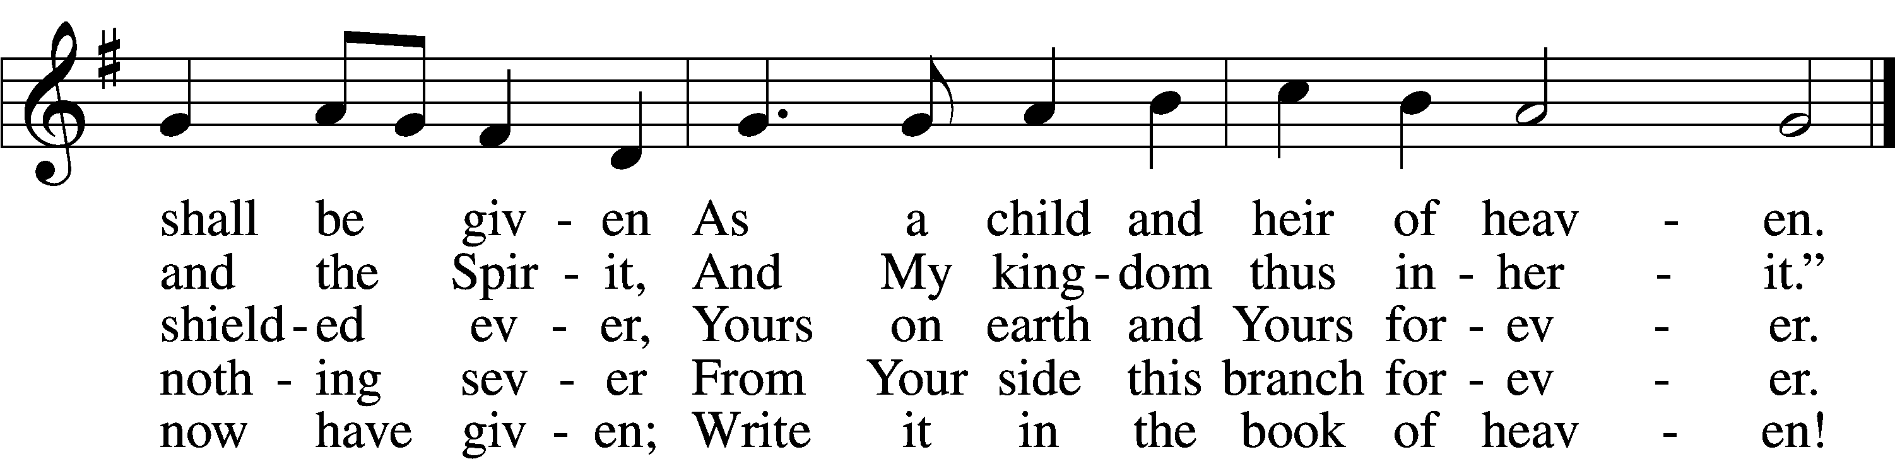

Text: Benjamin Schmolck, 1672–1737; tr. Catherine Winkworth, 1827–78, alt.  
Tune: Johann Rudolph Ahle, 1625–73, alt.  
Text and tune: Public domain

Baptism of Hayes Eugene Rees

The sign of the cross may be made by all in remembrance of their Baptism.

P In the name of the Father and of the T Son and of the Holy Spirit.

C **Amen.**

P Our help is in the name of the Lord,

C **who made heaven and earth.**

P If You, O Lord, kept a record of sins, O Lord, who could stand?

C **But with You there is forgiveness; therefore You are feared.**

P Since we are gathered to hear God’s Word, call upon Him in prayer and praise, and receive the body and blood of our Lord Jesus Christ in the fellowship of this altar, let us first consider our unworthiness and confess before God and one another that we have sinned in thought, word, and deed, and that we cannot free ourselves from our sinful condition. Together as His people let us take refuge in the infinite mercy of God, our heavenly Father, seeking His grace for the sake of Christ, and saying: God, be merciful to me, a sinner.

Kneel/Stand

C **Almighty God, have mercy upon us, forgive us our sins, and lead us to everlasting life. Amen.**

P Almighty God, merciful Father, in Holy Baptism You declared us to be Your children and gathered us into Your one, holy Church, in which You daily and richly forgive us our sins and grant us new life through Your Spirit. Be in our midst, enliven our faith, and graciously receive our prayer and praise; through Your Son, Jesus Christ, our Lord.

C **Amen.**

Stand

# Service of the Word

Introit Psalm 145:1–3, 6–7; antiphon: v. 5

P: On the glorious splendor of your majesty, and on your wondrous works, I will meditate.

**C: I will extol you, my God and King, and bless your name forever and ever.**

P: Every day I will bless you and praise your name forever and ever.

**C: Great is the Lord, and greatly to be praised, and his greatness is unsearchable.**

P: They shall speak of the might of your awesome deeds, and I will declare your greatness.

**C: They shall pour forth the fame of your abundant goodness and shall sing aloud of your righteousness.**

**All: Glory be to the Father and to the Son and to the Holy Spirit; as it was in the beginning, is now, and will be forever. Amen.**

P: On the glorious splendor of your majesty, and on your wondrous works, I will meditate.

Kyrie LSB 204

C **Lord, have mercy;**

**Christ, have mercy;**

**Lord, have mercy.**

Gloria in Excelsis LSB 204

C **1 To God on high be glory**

**And peace to all the earth;**

**Goodwill from God in heaven**

**Proclaimed at Jesus’ birth!**

**We praise and bless You, Father;**

**Your holy name, we sing—**

**Our thanks for Your great glory,**

**Lord God, our heav’nly King.**

**2 To You, O sole-begotten,**

**The Father’s Son, we pray;**

**O Lamb of God, our Savior,**

**You take our sins away.**

**Have mercy on us, Jesus;**

**Receive our heartfelt cry,**

**Where You in pow’r are seated**

**At God’s right hand on high—**

**3 For You alone are holy;**

**You only are the Lord.**

**Forever and forever,**

**Be worshiped and adored;**

**You with the Holy Spirit**

**Alone are Lord Most High,**

**In God the Father’s glory.**

**“Amen!” our glad reply.**

Text: Stephen P. Starke

Salutation and Collect of the Day

P The Lord be with you.

C **And also with you.**

P Let us pray.

**Almighty and most merciful God, the protector of all who trust in You, strengthen our faith and give us courage to believe that in Your love You will rescue us from all adversities; through Jesus Christ, Your Son, our Lord, who lives and reigns with You and the Holy Spirit, one God, now and forever.**

C **Amen.**

Sit

Old Testament Reading Genesis 9:8–17

8 God said to Noah and to his sons with him, 9“Behold, I establish my covenant with you and your offspring after you, 10and with every living creature that is with you, the birds, the livestock, and every beast of the earth with you, as many as came out of the ark; it is for every beast of the earth. 11I establish my covenant with you, that never again shall all flesh be cut off by the waters of the flood, and never again shall there be a flood to destroy the earth.” 12And God said, “This is the sign of the covenant that I make between me and you and every living creature that is with you, for all future generations: 13I have set my bow in the cloud, and it shall be a sign of the covenant between me and the earth. 14When I bring clouds over the earth and the bow is seen in the clouds, 15I will remember my covenant that is between me and you and every living creature of all flesh. And the waters shall never again become a flood to destroy all flesh. 16When the bow is in the clouds, I will see it and remember the everlasting covenant between God and every living creature of all flesh that is on the earth.” 17God said to Noah, “This is the sign of the covenant that I have established between me and all flesh that is on the earth.”

A This is the Word of the Lord.

C **Thanks be to God.**

Children’s Message

Epistle Ephesians 3:14–21

14For this reason I bow my knees before the Father, 15from whom every family in heaven and on earth is named, 16that according to the riches of his glory he may grant you to be strengthened with power through his Spirit in your inner being, 17so that Christ may dwell in your hearts through faith—that you, being rooted and grounded in love, 18may have strength to comprehend with all the saints what is the breadth and length and height and depth, 19and to know the love of Christ that surpasses knowledge, that you may be filled with all the fullness of God.

20Now to him who is able to do far more abundantly than all that we ask or think, according to the power at work within us, 21to him be glory in the church and in Christ Jesus throughout all generations, forever and ever. Amen.

A This is the Word of the Lord.

C **Thanks be to God.**

Stand

Alleluia and Verse

C **Alleluia, alleluia, alleluia.**

C **These things are written that you may believe that Jesus is the Christ, the Son of God.**

C **Alleluia, alleluia, alleluia.**

Holy Gospel Mark 6:45–56

P The Holy Gospel according to St. Mark, the sixth chapter.

C **Glory to You, O Lord.**

45Immediately [Jesus] made his disciples get into the boat and go before him to the other side, to Bethsaida, while he dismissed the crowd. 46And after he had taken leave of them, he went up on the mountain to pray. 47And when evening came, the boat was out on the sea, and he was alone on the land. 48And he saw that they were making headway painfully, for the wind was against them. And about the fourth watch of the night he came to them, walking on the sea. He meant to pass by them, 49but when they saw him walking on the sea they thought it was a ghost, and cried out, 50for they all saw him and were terrified. But immediately he spoke to them and said, “Take heart; it is I. Do not be afraid.” 51And he got into the boat with them, and the wind ceased. And they were utterly astounded, 52for they did not understand about the loaves, but their hearts were hardened.

53When they had crossed over, they came to land at Gennesaret and moored to the shore. 54And when they got out of the boat, the people immediately recognized him 55and ran about the whole region and began to bring the sick people on their beds to wherever they heard he was. 56And wherever he came, in villages, cities, or countryside, they laid the sick in the marketplaces and implored him that they might touch even the fringe of his garment. And as many as touched it were made well.

P This is the Gospel of the Lord.

C **Praise to You, O Christ.**

Nicene Creed

C **I believe in one God, the Father Almighty, maker of heaven and earth and of all things visible and invisible.**

**And in one Lord Jesus Christ, the only-begotten Son of God, begotten of His Father before all worlds, God of God, Light of Light, very God of very God, begotten, not made, being of one substance with the Father, by whom all things were made; who for us men and for our salvation came down from heaven and was incarnate by the Holy Spirit of the virgin Mary and was made man; and was crucified also for us under Pontius Pilate. He suffered and was buried. And the third day He rose again according to the Scriptures and ascended into heaven and sits at the right hand of the Father. And He will come again with glory to judge both the living and the dead, whose kingdom will have no end.**

**And I believe in the Holy Spirit, the Lord and giver of life, who proceeds from the Father and the Son, who with the Father and the Son together is worshiped and glorified, who spoke by the prophets. And I believe in one holy Christian and apostolic Church, I acknowledge one Baptism for the remission of sins, and I look for the resurrection of the dead and the life** T **of the world to come. Amen.**

Sit

731 O God, Forsake Me Not

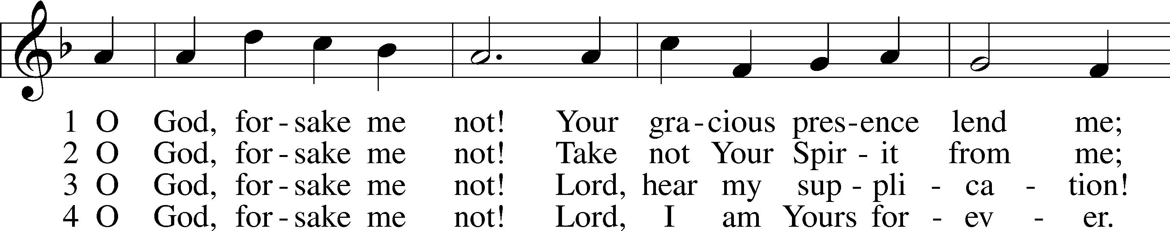

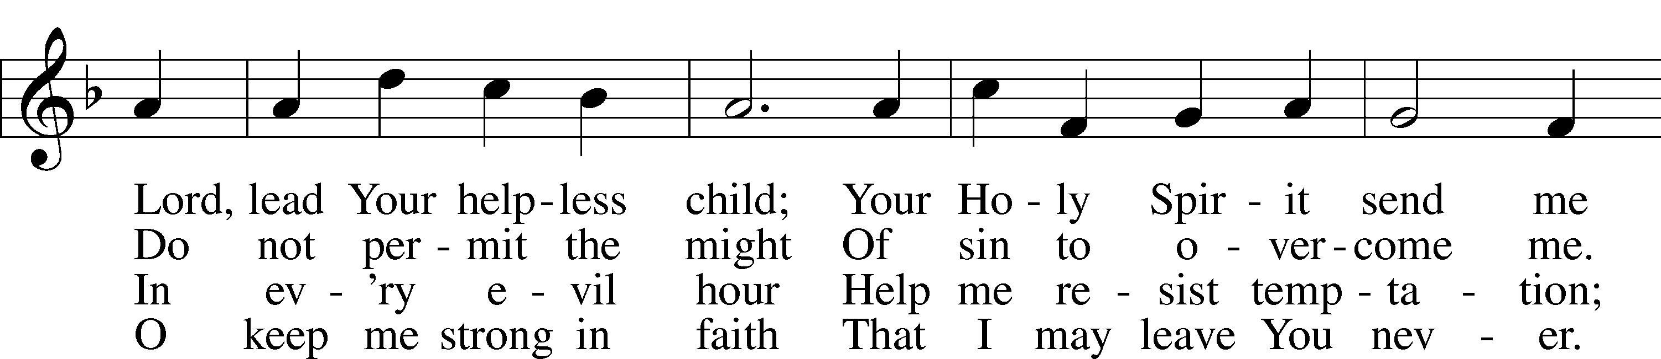

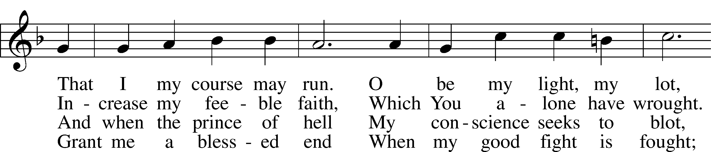

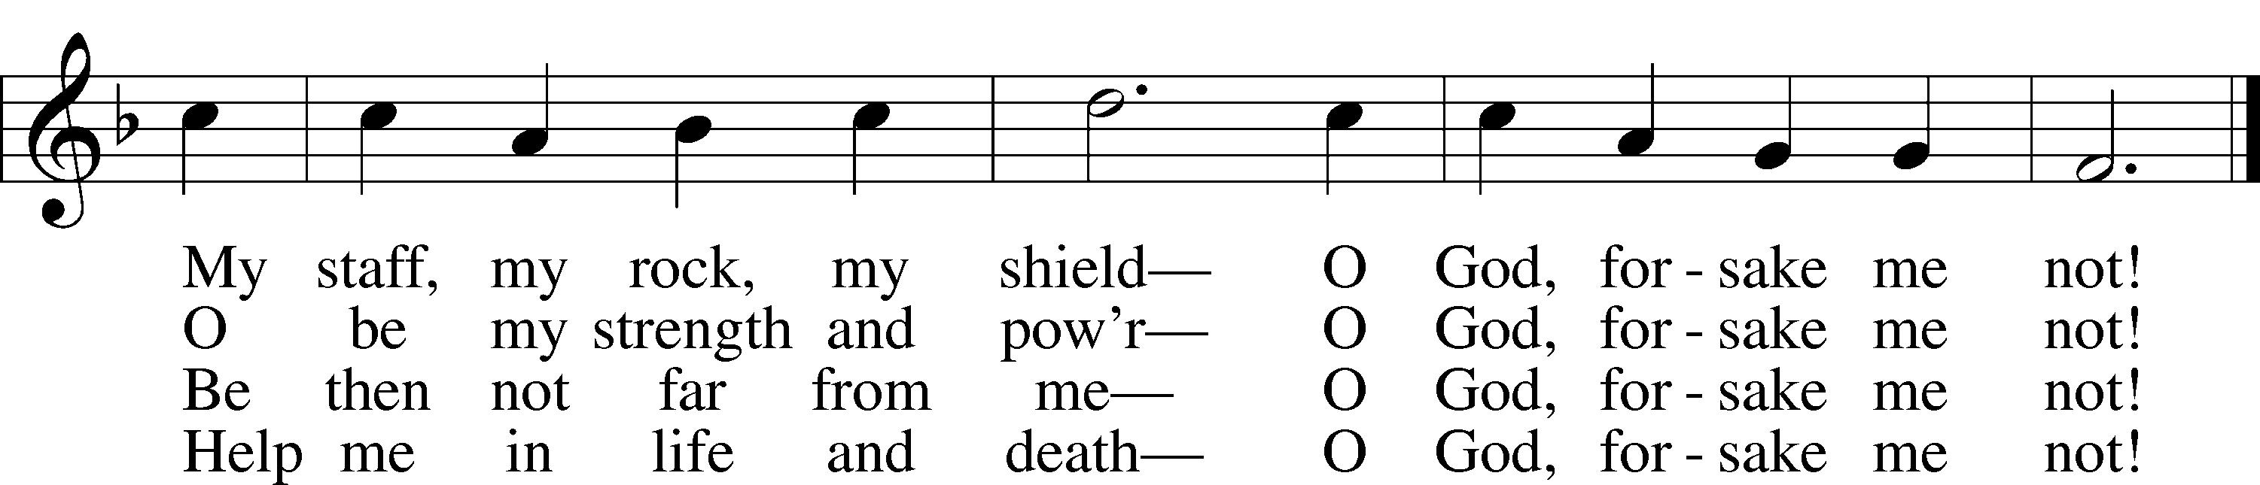

Text: Salomo Franck, 1659–1725; tr. August Crull, 1845–1923, alt.  
Tune: Neu-vermehrtes . . . Gesangbuch, 1693, 3rd ed., Meiningen  
Text and tune: Public domain

Sermon

Stand / Prayer of the Church

Sit / Offering

# Service of the Sacrament *(please rise)*

Preface LSB 208

P The Lord be with you.

C **And also with you.**

P Lift up your hearts.

C **We lift them to the Lord.**

P Let us give thanks to the Lord our God.

C **It is right to give Him thanks and praise.**

P It is truly good, right, and salutary that we should at all times and in all places give thanks to You, O Lord, holy Father, almighty and everlasting God, for the countless blessings You so freely bestow on us and all creation. Above all, we give thanks for Your boundless love shown to us when You sent Your only-begotten Son, Jesus Christ, into our flesh and laid on Him our sin, giving Him into death that we might not die eternally. Because He is now risen from the dead and lives and reigns to all eternity, all who believe in Him will overcome sin and death and will rise again to new life. Therefore with angels and archangels and with all the company of heaven we laud and magnify Your glorious name, evermore praising You and saying:

Sanctus LSB 208

C **Holy, holy, holy Lord God of Sabaoth adored;**

**Heav’n and earth with full acclaim shout the glory of Your name.**

**Sing hosanna in the highest, sing hosanna to the Lord;**

**Truly blest is He who comes in the name of the Lord!**

Text: Stephen P. Starke

Prayer of Thanksgiving

P Blessed are You, O Lord our God, king of all creation, for You have had mercy on us and given Your only-begotten Son that whoever believes in Him should not perish but have eternal life.

In Your righteous judgment You condemned the sin of Adam and Eve, who ate the forbidden fruit, and You justly barred them and all their children from the tree of life. Yet, in Your great mercy, You promised salvation by a second Adam, Your Son, Jesus Christ, our Lord, and made His cross a life-giving tree for all who trust in Him.

We give You thanks for the redemption You have prepared for us through Jesus Christ. Grant us Your Holy Spirit that we may faithfully eat and drink of the fruits of His cross and receive the blessings of forgiveness, life, and salvation that come to us in His body and blood.

Hear us as we pray in His name and as He has taught us:

Lord’s Prayer

C **Our Father who art in heaven, hallowed be Thy name,**

**Thy kingdom come, Thy will be done on earth as it is in heaven;**

**give us this day our daily bread;**

**and forgive us our trespasses as we forgive those who trespass against us;**

**and lead us not into temptation, but deliver us from evil.**

**For Thine is the kingdom and the power and the glory forever and ever. Amen.**

The Words of Our Lord

P Our Lord Jesus Christ, on the night when He was betrayed, took bread, and when He had given thanks, He broke it and gave it to the disciples and said: “Take, eat; this is My T body, which is given for you. This do in remembrance of Me.”

In the same way also He took the cup after supper, and when He had given thanks, He gave it to them, saying: “Drink of it, all of you; this cup is the new testament in My T blood, which is shed for you for the forgiveness of sins. This do, as often as you drink it, in remembrance of Me.”

Pax Domini

P The peace of the Lord be with you always.

C **Amen.**

Agnus Dei LSB 210

C **1 O Jesus Christ, true Lamb of God,**

**You take the sin of the world away;**

**O Jesus Christ, true Lamb of God,**

**Have mercy on us, Lord, we pray.**

**2 O Jesus Christ, true Lamb of God,**

**You take the sin of the world away;**

**Have mercy on us, Jesus Christ,**

**And grant us peace, O Lord, we pray.**

Text: Stephen P. Starke

Sit

Distribution

The pastor and those who assist him receive the body and blood of Christ first and then distribute them to those who come to receive, saying:

Take, eat; this is the true body of our Lord and Savior Jesus Christ, given into death for your sins. **Amen.**

Take, drink; this is the true blood of our Lord and Savior Jesus Christ, shed for the forgiveness of your sins. **Amen.**

In dismissing the communicants, the following is said:

P The body and blood of our Lord Jesus Christ strengthen and preserve you in body and soul to life everlasting. Depart T in peace.

C **Amen.**

587 I Know My Faith Is Founded

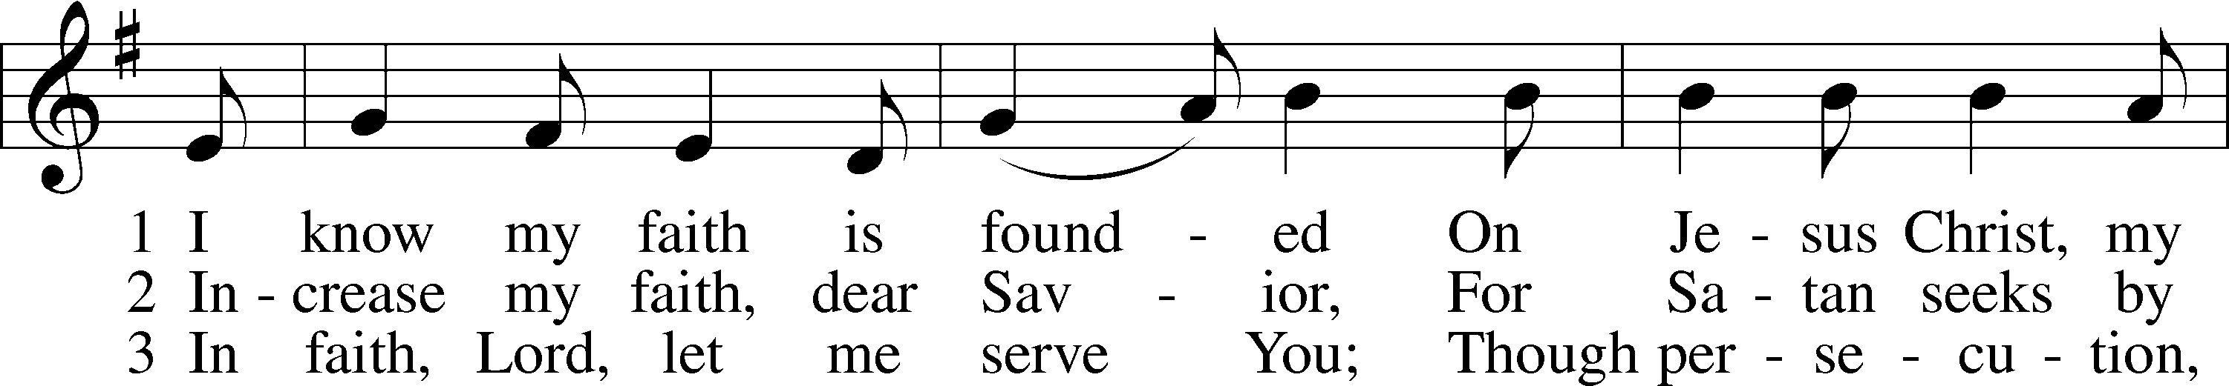

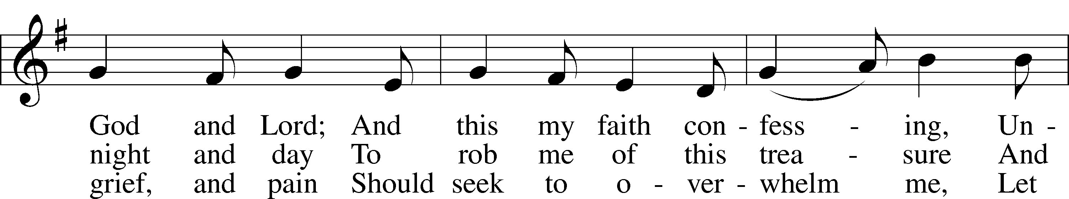

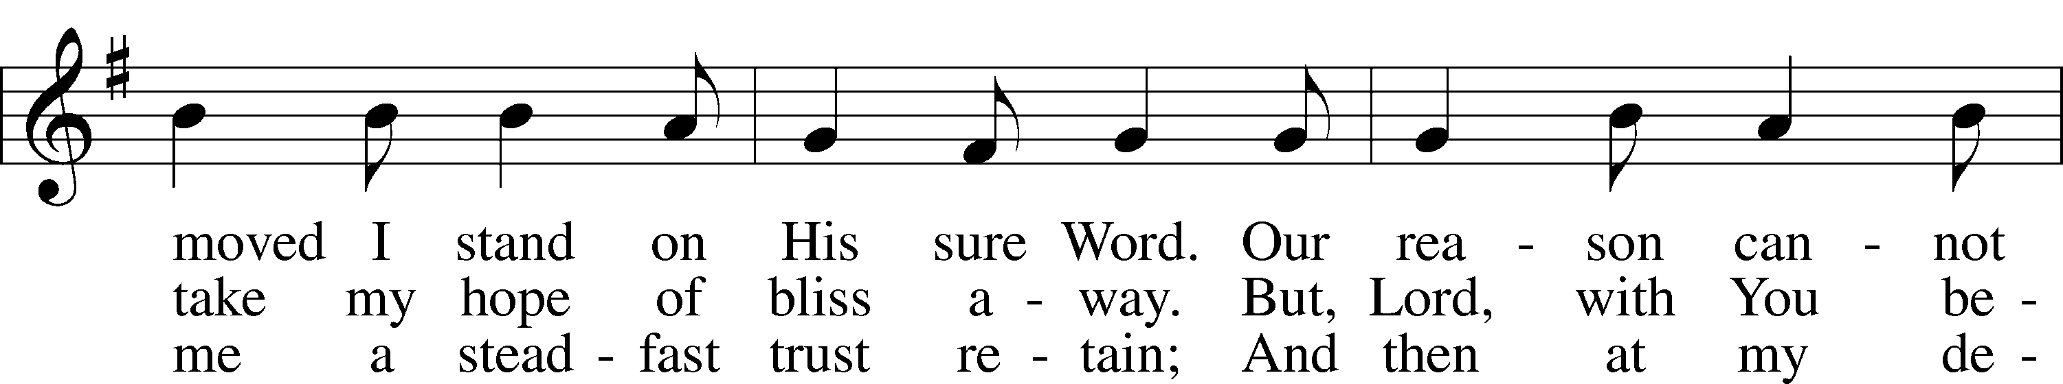

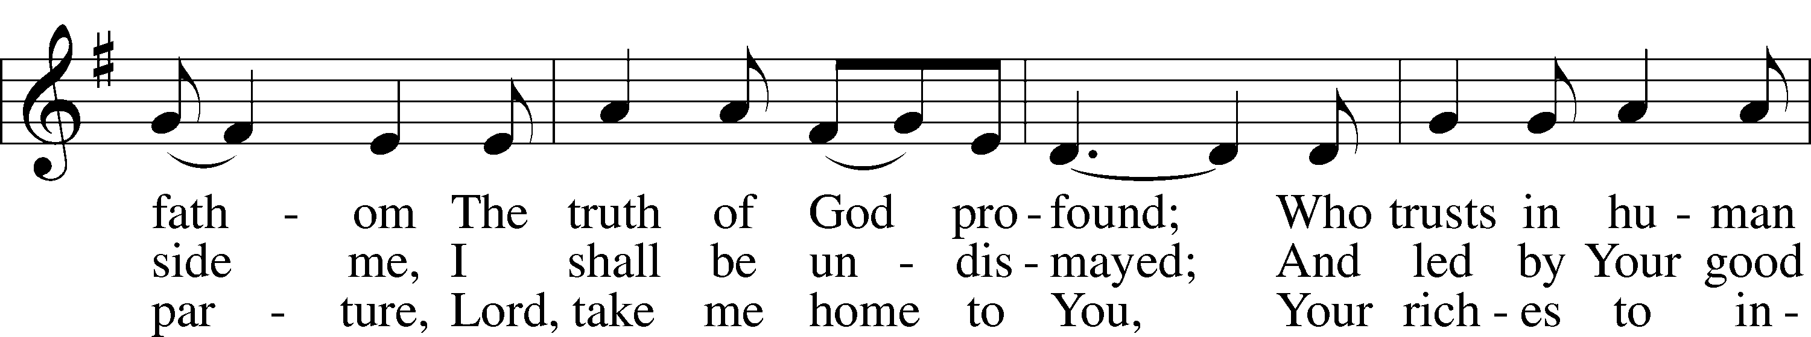

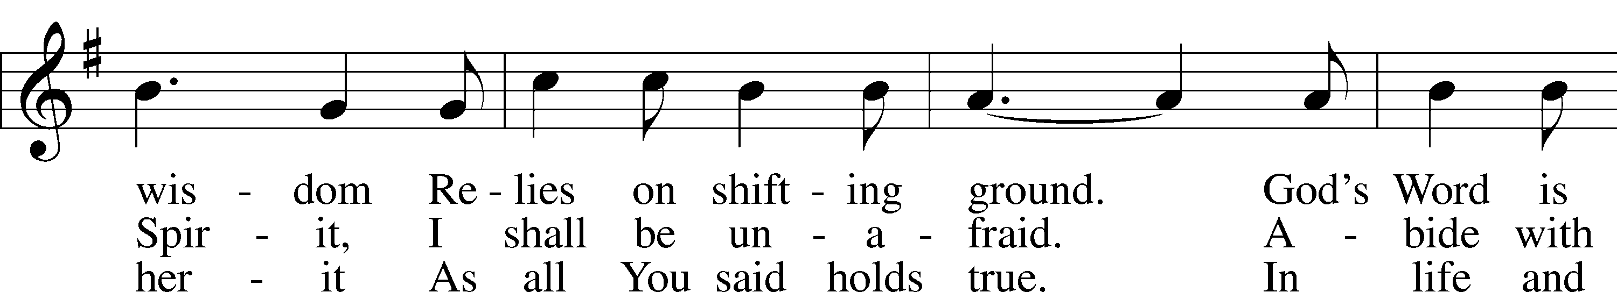

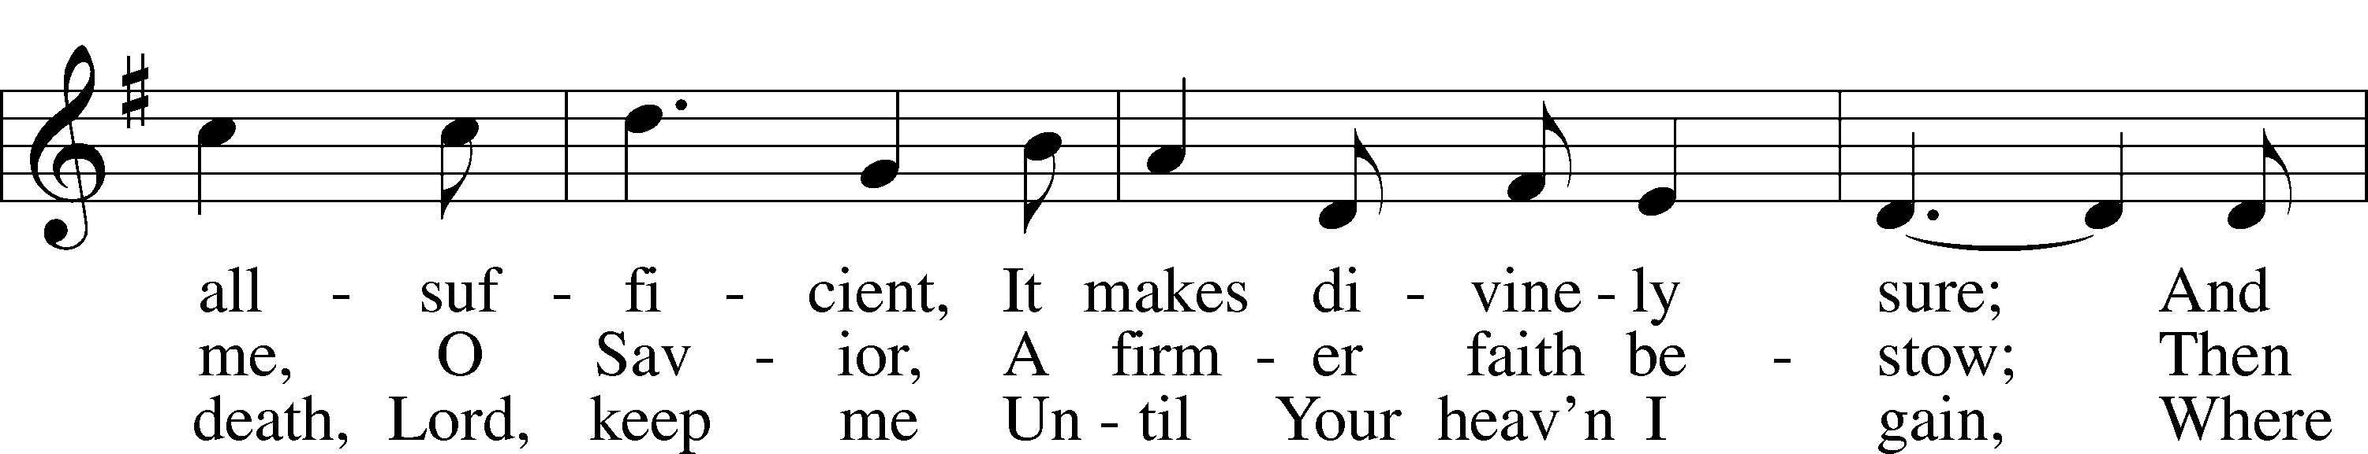

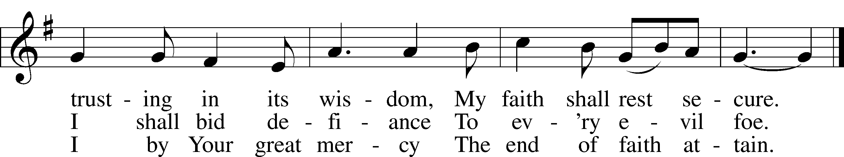

Text: Erdmann Neumeister, 1671–1756; tr. The Lutheran Hymnal, 1941, alt.  
Tune: Concentus novi, 1540, Augsburg  
Text and tune: Public domain

602 The Gifts Christ Freely Gives

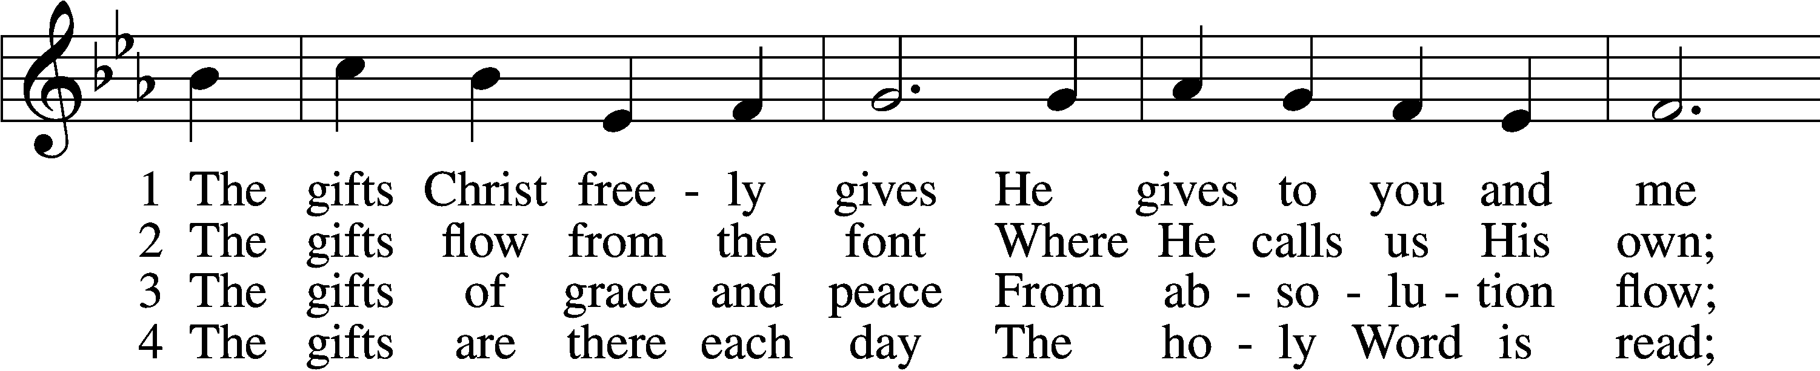

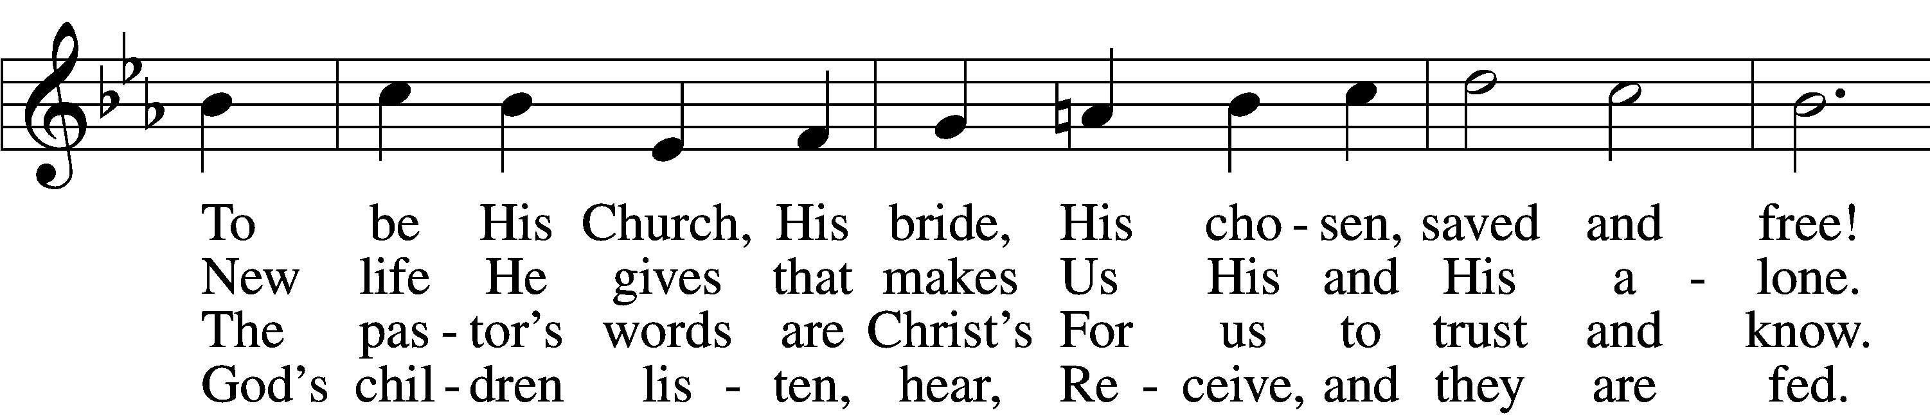

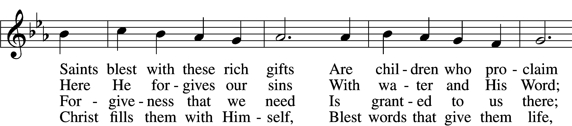

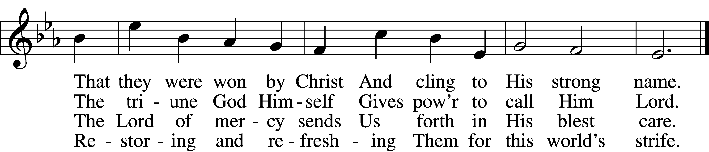

5 The gifts are in the feast,  
 Gifts far more than we see;  
Beneath the bread and wine  
 Is food from Calvary.  
The body and the blood  
 Remove our ev’ry sin;  
We leave His presence in  
 His peace, renewed again.

6 All glory to the One  
 Who lavishes such love;  
The triune God in love  
 Assures our life above.  
His means of grace for us  
 Are gifts He loves to give;  
All thanks and praise for His  
 Great love by which we live!

Text: Richard C. Resch, 1947  
Tune: Charles J. Dale, 1842–1912, alt.  
Text: © 2001 Richard C. Resch. Used by permission: LSB Hymn License no. 110003789  
Tune: Public domain

821 Alleluia! Sing to Jesus

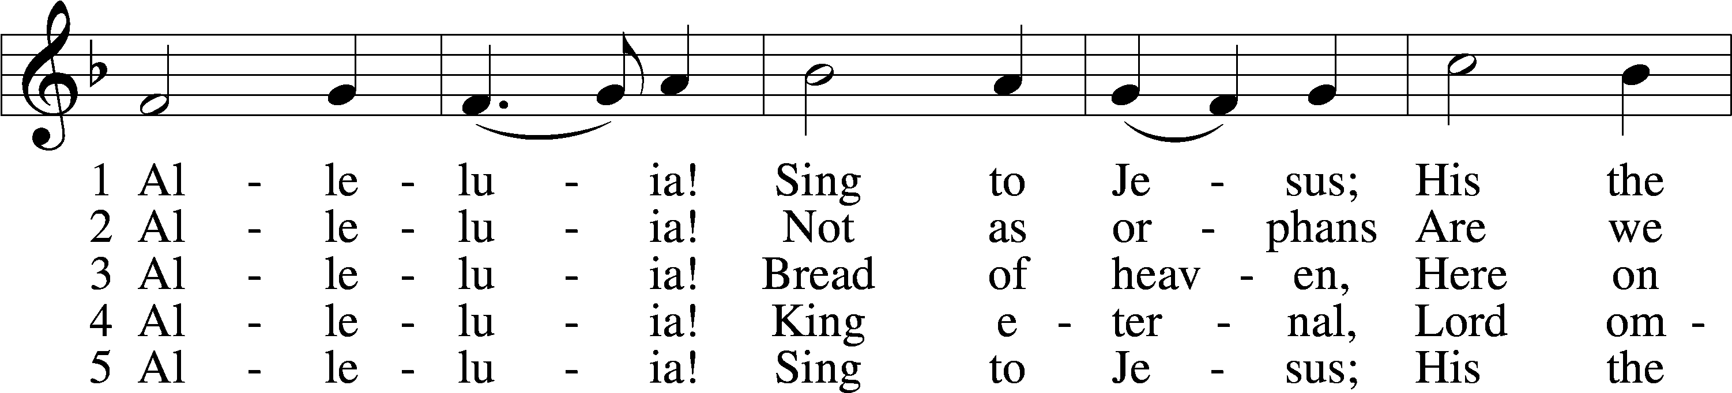

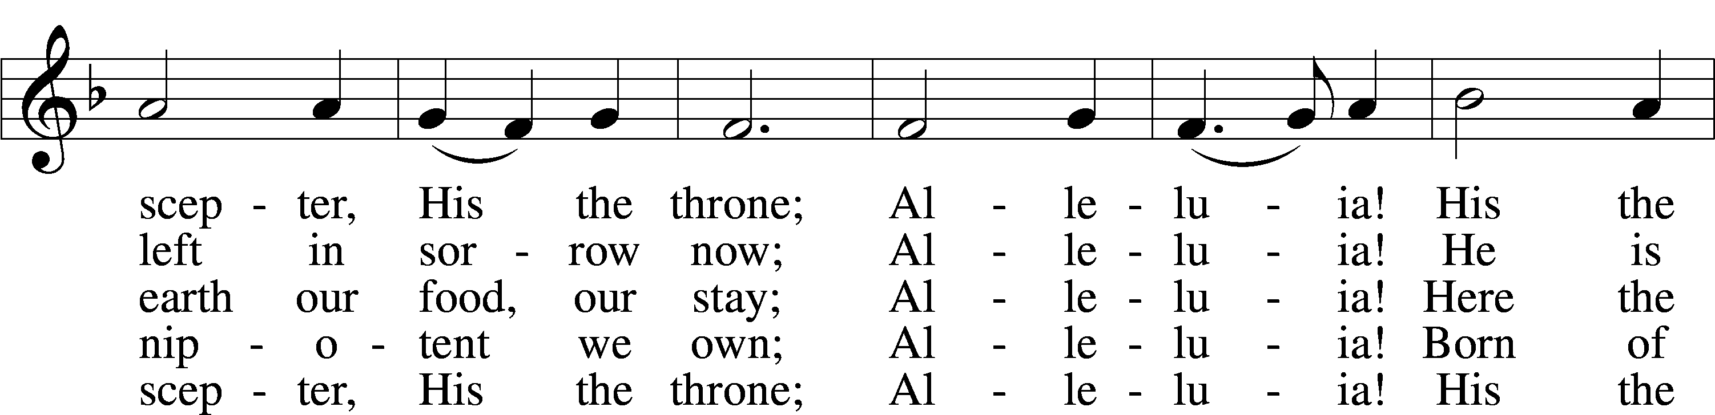

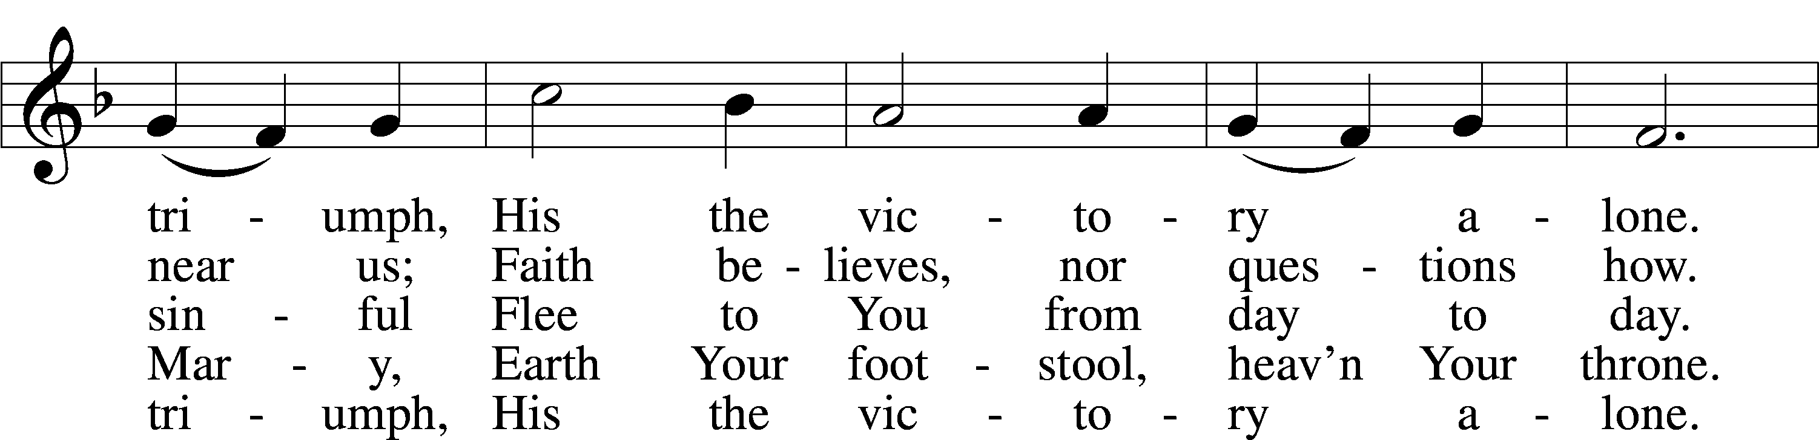

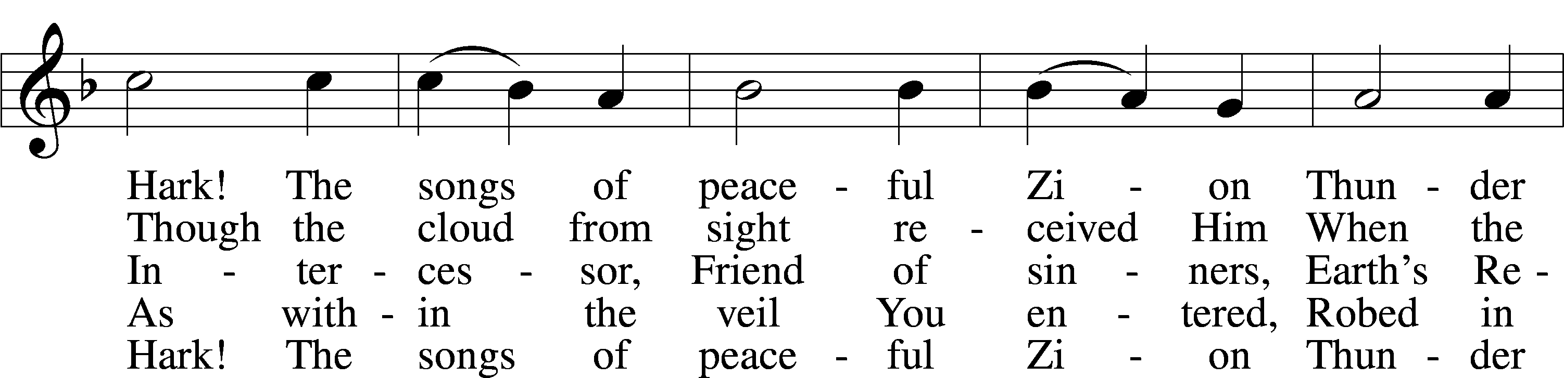

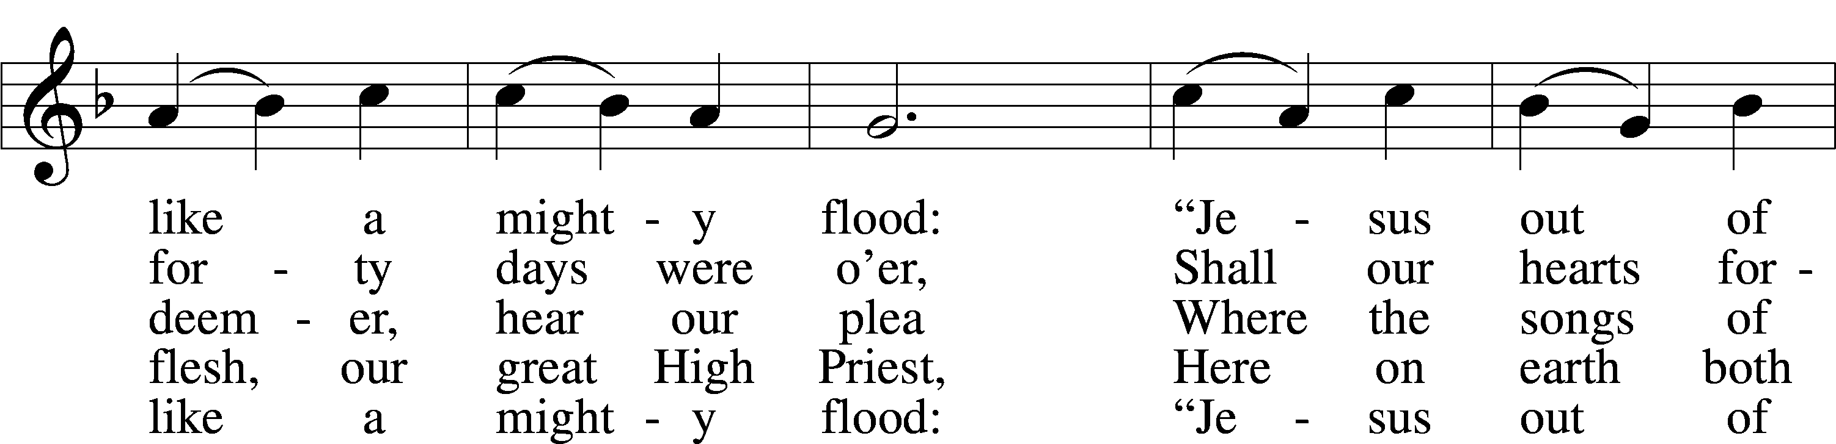

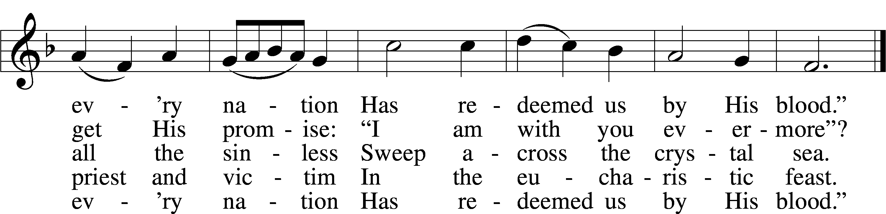

Text: William C. Dix, 1837–98, alt.  
Tune: Rowland H. Prichard, 1811–87  
Text and tune: Public domain

Stand

Nunc Dimittis LSB 211

C **1 O Lord, now let Your servant**

**Depart in heav’nly peace,**

**For I have seen the glory**

**Of Your redeeming grace:**

**A light to lead the Gentiles**

**Unto Your holy hill,**

**The glory of Your people,**

**Your chosen Israel.**

**2 All glory to the Father,**

**All glory to the Son,**

**All glory to the Spirit,**

**Forever Three in One;**

**For as in the beginning,**

**Is now, shall ever be,**

**God’s triune name resounding**

**Through all eternity.**

Post-Communion Collect

A Let us pray.

We give thanks to You, almighty God, that You have refreshed us through this salutary gift, and we implore You that of Your mercy You would strengthen us through the same in faith toward You and in fervent love toward one another; through Jesus Christ, Your Son, our Lord, who lives and reigns with You and the Holy Spirit, one God, now and forever.

C **Amen.**

Benedicamus LSB 212

A Let us bless the Lord.

C **Thanks be to God.**

Benediction

P The Lord bless you and keep you.

The Lord make His face shine on you and be gracious to you.

The Lord look upon you with favor and T give you peace.

C **Amen.**

643 Sent Forth by God’s Blessing

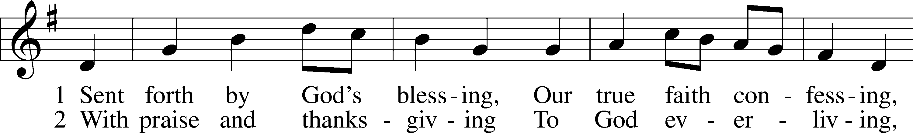

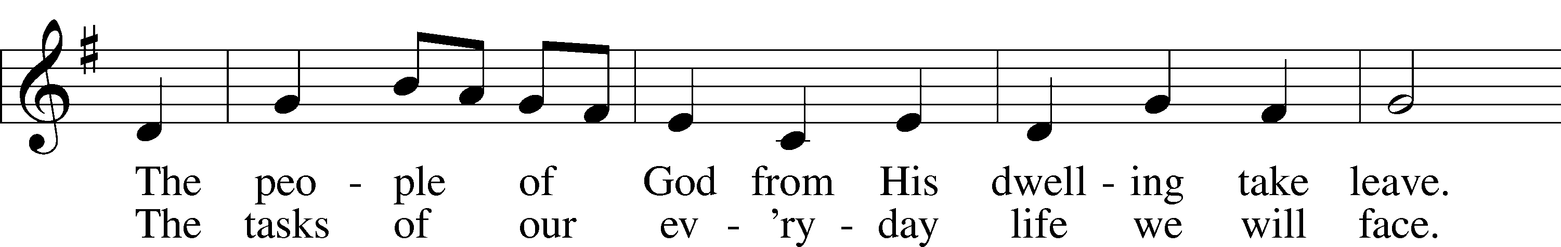

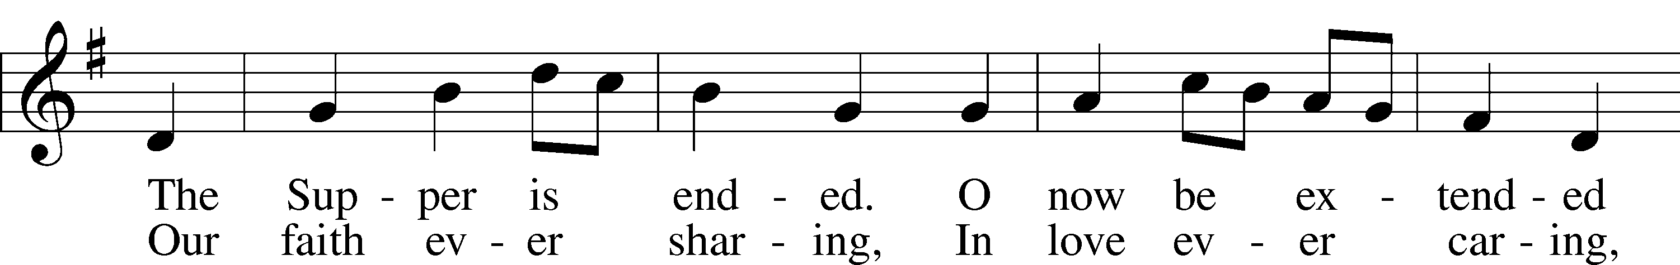

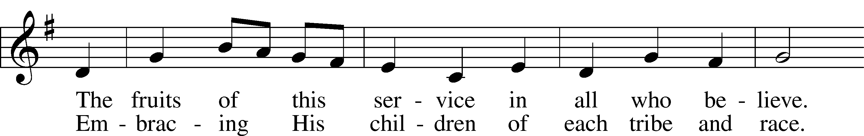

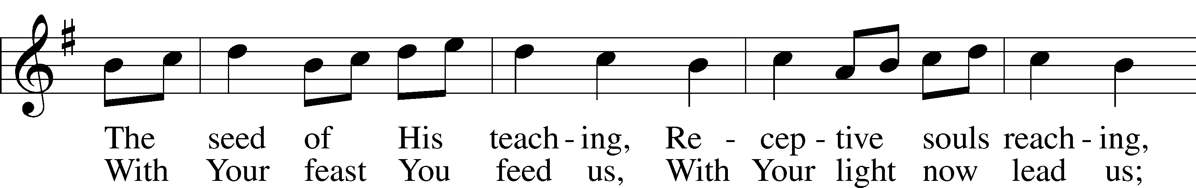

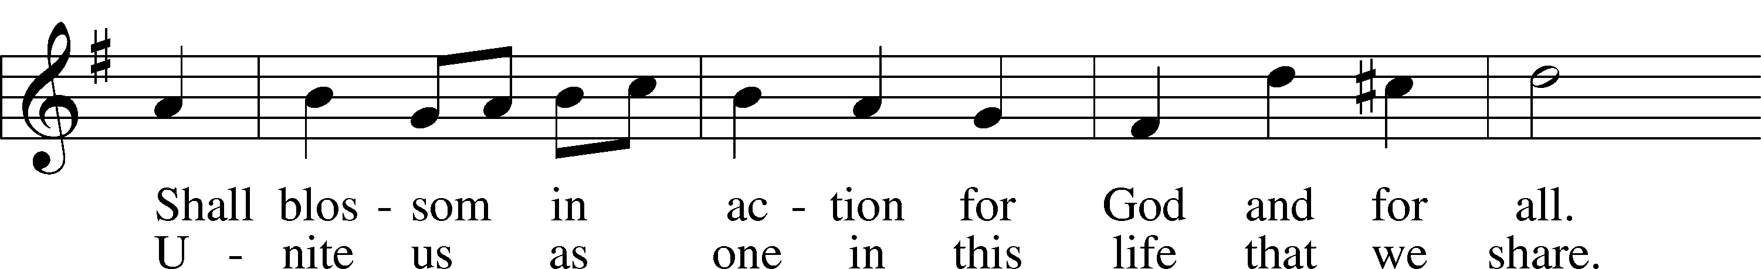

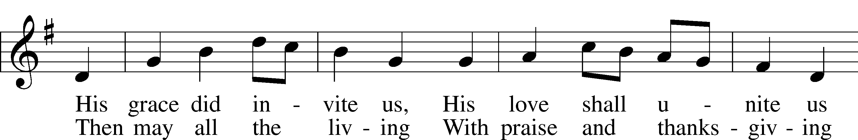

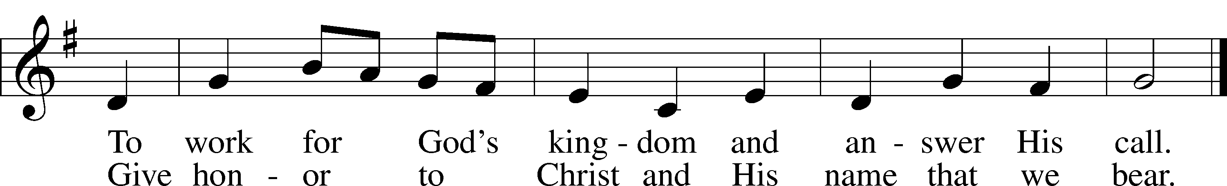

Text: Omer E. Westendorf, 1916–97, alt.  
Tune: Welsh  
Text: © 1964 World Library Publications. Used by permission: LSB Hymn License no. 110003789  
Tune: Public domain

Acknowledgments

Divine Service, Setting Four from Lutheran Service Book

Unless otherwise indicated, Scripture quotations are from the ESV® Bible (The Holy Bible, English Standard Version®), copyright © 2001 by Crossway, a publishing ministry of Good News Publishers. Used by permission. All rights reserved.

Created by Lutheran Service Builder © 2024 Concordia Publishing House.

**PRAYERS**

Mike Balderson, Larry Bergmeier, Mickey Brunkhorst, Allen Bures, Bill Coffendaffer, Donna Crannell,

Gail Custer, Joyce Custer, David Dawson, Jason Dendinger, Jennifer Fortkamp, Cami Friedrichs,

Delbert Grefe, Wanda Grefe, Connie Heidebrecht, Sheri Hibbert, Kandy Ingram, Dorothy Lindquist,

Ken Marshall, Mary Lou Meeriam, Dale Meineke, Darlene Menniga, Eunice Meyer, Deb Minge,

Stan Ohlde, Karen Oldehoeft, Phyllis O’Toole, Dan Rash, Ryan Ricenbaw, Joyce Richter, Dean Rosenthal, Kaleb Rupprecht, Linda Russell, Dorothy Scheele, Merlin Scheele, James Snyder, Kristina Snyder,

Sindy Snyder, Troy Stauffer, Lorrie Stierwalt, Lawerence Vitosh, Noah Vitosh, Gene Weilage,

Mary Wieters, Loretta Williams, Tony Young

*(Loved ones are kept on the prayer list unless otherwise requested)*

**Pray for our Military:** Active Duty: Frank Lanagan, stationed in Alaska; Liam Blum, stationed in Japan.

**Birthdays:** Kathy Adam (07/29); Kathy Haecker (07/30); Neely Eickman, Banner Kostal, Lexi Riggert,

Janet Vitosh (08/01); Hannah Penner, Sierra Schroeder (08/02); Steph Shelly, Tyler Vitosh (08/03)

**Baptismal Birthdays:** Lance Gehring, Todd Gehring, Tracy Hutchinson (07/30); Josh Ming

e,

Lawerence Vitosh (07/31); Andy Adam (08/01)

**Anniversaries:**

**Calendar of Events**

Sun. 07/28 9:00 am Divine Service w/Communion

Voters’ Mtg. following the service

Wed. 07/31 7:00 pm Chosen “4”

Sun. 08/04 9:00 am Divine Service w/Communion

10:00 am Adult Bible Study

Worship Assistants for Sunday, July 28th

Greeters: **Ed & Carol Scheele**

Reader: **Lynn Henrichs** Acolyte: **Madison P.**

Worship Assistants for Sunday, August 4th

Greeters: **Robin Jones & Parker Jones**

Reader: **Joyce Kostal** Acolyte: **Kyler**

**ANNOUNCEMENTS**

Welcome our newest member Hayes Rees!

Voters’ Mtg. today following the service.

Chosen “4” will be shown on Wednesday evenings at 7 pm. Please join us!

Communion will be held on the 1st & 3rd Sundays in August. The Homestead Harmonizers will be here on Sunday, August 11th. The service will be moved to 10 am on that Sunday to accommodate them.

Youth will be selling sweet corn. They will let people know when the corn is ready and for sale.

Ellis & Odell United Methodist Churches will be hosting an ice cream social on Sunday, August 18th from 4-6 pm @ the Ellis United Methodist Church. Poster on bulletin board with the details. Mark your calendar.